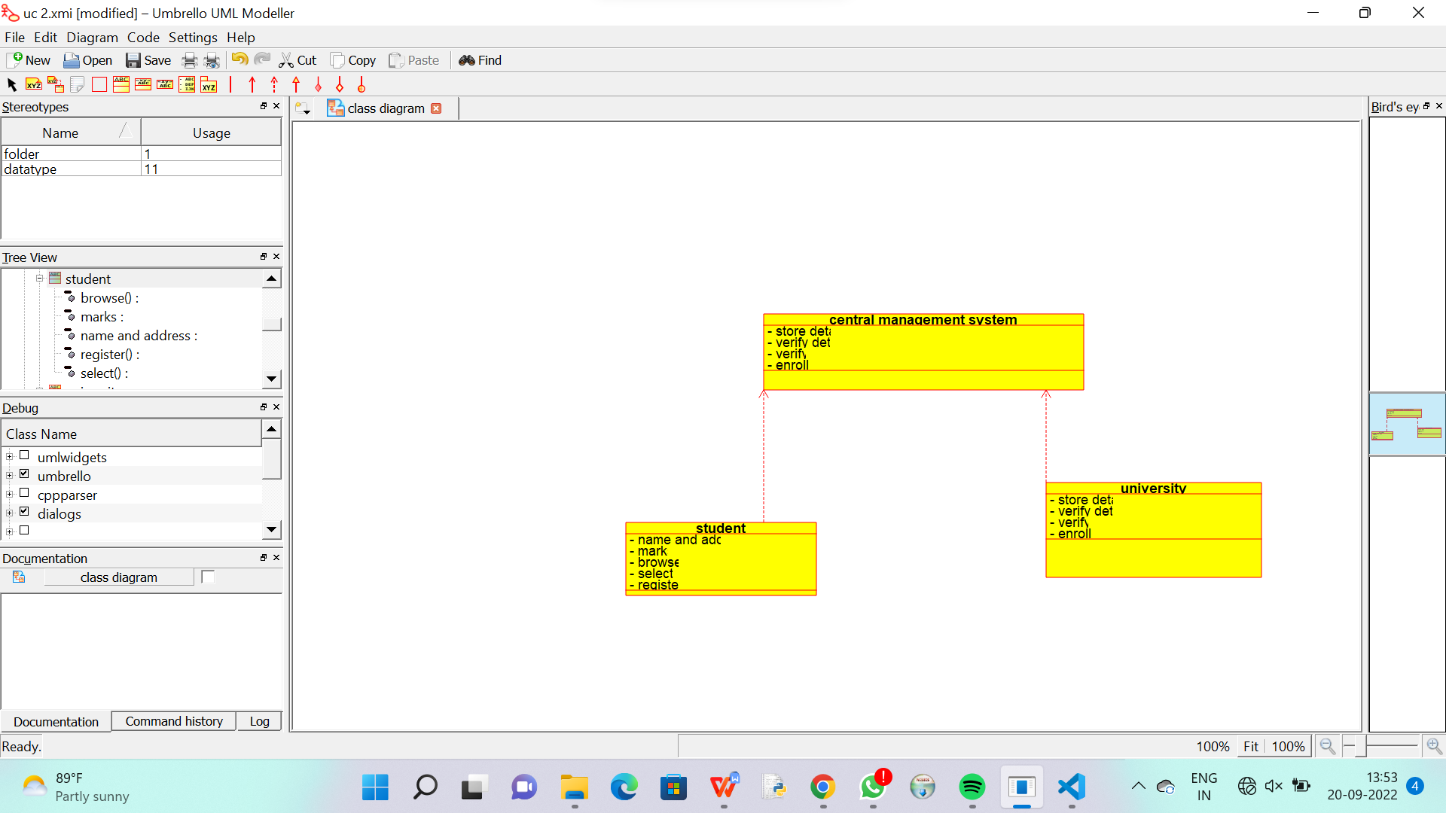

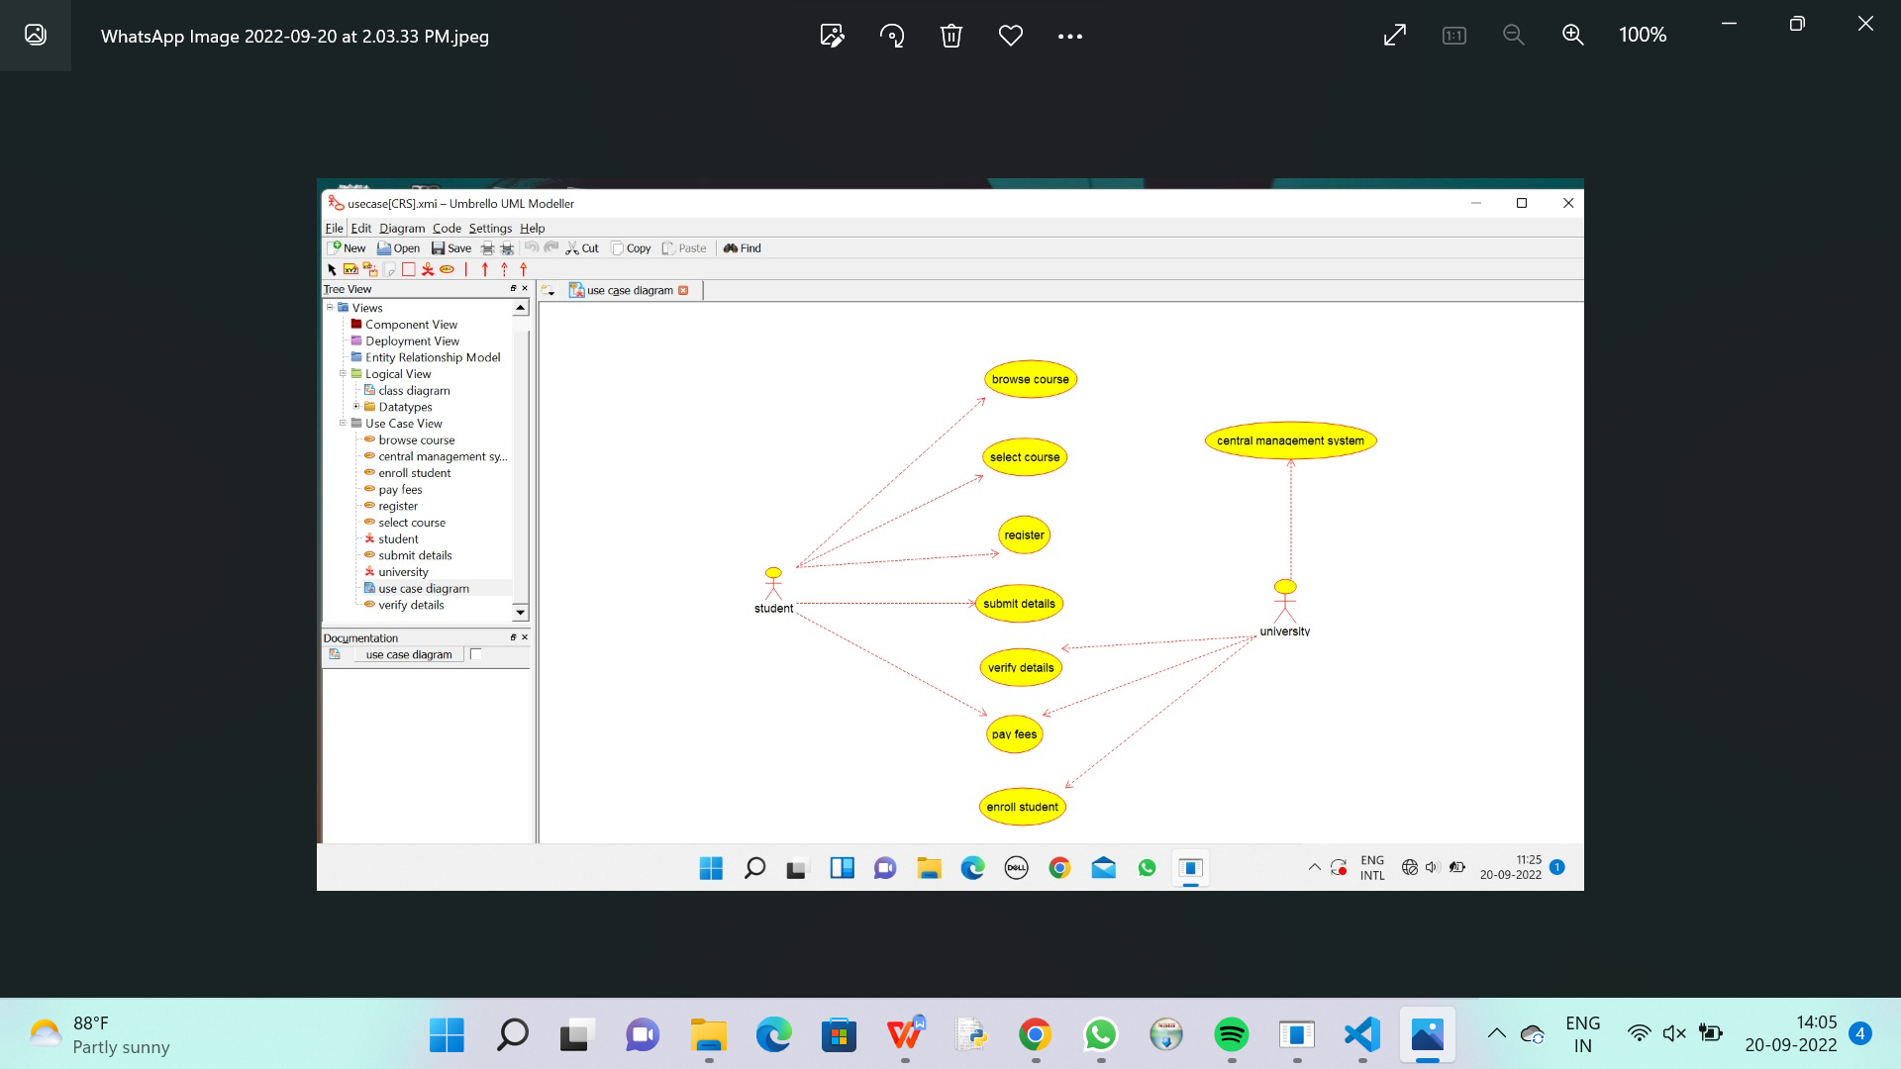

/**

 * Class student

 */

public class student {

  //

  // Fields

  //

  private void name_and_address;

  private void marks;

  private void browse_;

  private void select_;

  private void register_;

  //

  // Constructors

  //

  public student () { };

  //

  // Methods

  //

  //

  // Accessor methods

  //

  /**

   * Set the value of name_and_address

   * @param newVar the new value of name_and_address

   */

  private void setName_and_address (void newVar) {

    name_and_address = newVar;

  }

  /**

   * Get the value of name_and_address

   * @return the value of name_and_address

   */

  private void getName_and_address () {

    return name_and_address;

  }

  /**

   * Set the value of marks

   * @param newVar the new value of marks

   */

  private void setMarks (void newVar) {

    marks = newVar;

  }

  /**

   * Get the value of marks

   * @return the value of marks

   */

  private void getMarks () {

    return marks;

  }

  /**

   * Set the value of browse_

   * @param newVar the new value of browse_

   */

  private void setBrowse_ (void newVar) {

    browse_ = newVar;

  }

  /**

   * Get the value of browse_

   * @return the value of browse_

   */

  private void getBrowse_ () {

    return browse_;

  }

  /**

   * Set the value of select_

   * @param newVar the new value of select_

   */

  private void setSelect_ (void newVar) {

    select_ = newVar;

  }

  /**

   * Get the value of select_

   * @return the value of select_

   */

  private void getSelect_ () {

    return select_;

  }

  /**

   * Set the value of register_

   * @param newVar the new value of register_

   */

  private void setRegister_ (void newVar) {

    register_ = newVar;

  }

  /**

   * Get the value of register_

   * @return the value of register_

   */

  private void getRegister_ () {

    return register_;

  }

  //

  // Other methods

  //

}

/**

 * Class university

 */

public class university {

  //

  // Fields

  //

  private void store_details;

  private void verify_details;

  private void verify_;

  private void enroll_;

  //

  // Constructors

  //

  public university () { };

  //

  // Methods

  //

  //

  // Accessor methods

  //

  /**

   * Set the value of store_details

   * @param newVar the new value of store_details

   */

  private void setStore_details (void newVar) {

    store_details = newVar;

  }

  /**

   * Get the value of store_details

   * @return the value of store_details

   */

  private void getStore_details () {

    return store_details;

  }

  /**

   * Set the value of verify_details

   * @param newVar the new value of verify_details

   */

  private void setVerify_details (void newVar) {

    verify_details = newVar;

  }

  /**

   * Get the value of verify_details

   * @return the value of verify_details

   */

  private void getVerify_details () {

    return verify_details;

  }

  /**

   * Set the value of verify_

   * @param newVar the new value of verify_

   */

  private void setVerify_ (void newVar) {

    verify_ = newVar;

  }

  /**

   * Get the value of verify_

   * @return the value of verify_

   */

  private void getVerify_ () {

    return verify_;

  }

  /**

   * Set the value of enroll_

   * @param newVar the new value of enroll_

   */

  private void setEnroll_ (void newVar) {

    enroll_ = newVar;

  }

  /**

   * Get the value of enroll_

   * @return the value of enroll_

   */

  private void getEnroll_ () {

    return enroll_;

  }

  //

  // Other methods

  //

}

/**

 * Class central_management_system

 */

public class central_management_system {

  //

  // Fields

  //

  private void store_details;

  private void verify_details;

  private void verify_;

  private void enroll_;

  //

  // Constructors

  //

  public central_management_system () { };

  //

  // Methods

  //

  //

  // Accessor methods

  //

  /**

   * Set the value of store_details

   * @param newVar the new value of store_details

   */

  private void setStore_details (void newVar) {

    store_details = newVar;

  }

  /**

   * Get the value of store_details

   * @return the value of store_details

   */

  private void getStore_details () {

    return store_details;

  }

  /**

   * Set the value of verify_details

   * @param newVar the new value of verify_details

   */

  private void setVerify_details (void newVar) {

    verify_details = newVar;

  }

  /**

   * Get the value of verify_details

   * @return the value of verify_details

   */

  private void getVerify_details () {

    return verify_details;

  }

  /**

   * Set the value of verify_

   * @param newVar the new value of verify_

   */

  private void setVerify_ (void newVar) {

    verify_ = newVar;

  }

  /**

   * Get the value of verify_

   * @return the value of verify_

   */

  private void getVerify_ () {

    return verify_;

  }

  /**

   * Set the value of enroll_

   * @param newVar the new value of enroll_

   */

  private void setEnroll_ (void newVar) {

    enroll_ = newVar;

  }

  /**

   * Get the value of enroll_

   * @return the value of enroll_

   */

  private void getEnroll_ () {

    return enroll_;

  }

  //

  // Other methods

  //

}